# Styles and Moods and the Comics Zeitgeist

Over the past several decades, I’ve pondered what is the equivalent of the chicken-and-the egg question in comics: how much does the art drive the writing versus the other way around and how does the tension between these different creative outlets shape the final story. In a previous column, I looked at this from the point of view of a specific pairing of writer and artist. Last month, I looked at the statistics associated with the mechanical aspects of making a page. This month I thought I would conduct a survey of styles and moods across comics history, starting with the beginning of the Golden Age in the late 1930s. The samples presented here are part of the larger set I used last month.

I am a sucker for the old school, Golden Age comics (at least most of them). They seem to have a certain charm in the art style and the choice of word and phrase. Consider the following page from *Marvel Comics* #1 (technically the reprint version made freely available as part of Halloween ComicFest in 2014). 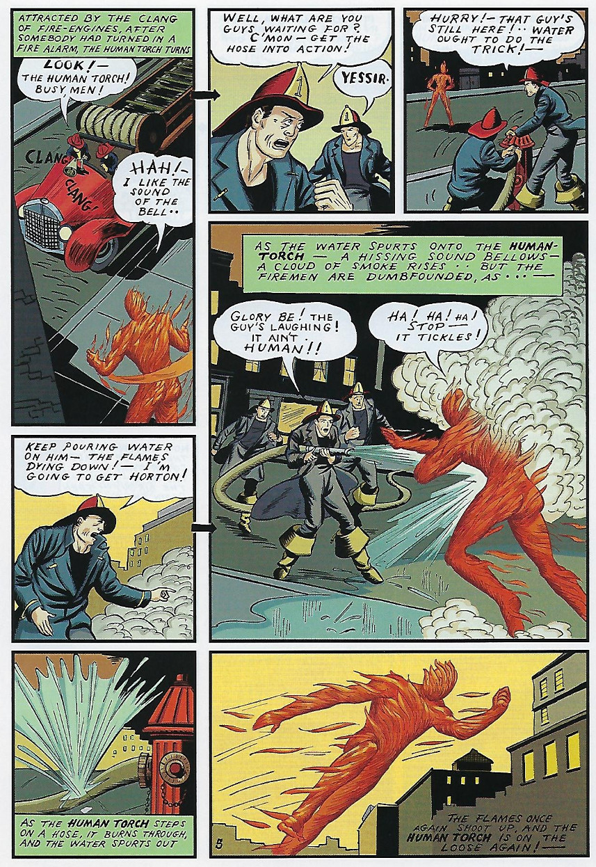

If you didn’t know where the above snippet was from, there is still a good chance, even if you aren’t a comics aficionado, that you would be able to predict is was ‘old timey’ (1939 being the year that this was first published).

What makes it so distinctive? Clearly it is one part art style, one part panel layout, one part subject matter, and one part word choice and location. There is a certain zeitgeist that comics of this era have – a collective way of thinking about and presenting the story that makes it distinctive – much like the movies of the 1930s and 1940s. Even more distinctive than the art, the attitude of the main characters signal the period in U.S. history when this was produced. The Human Torch seems completely unconcerned about the havoc he is wreaking and the firefighters act completely unconcerned about their own safety. There is a certain carefree quality that typically marks the stories from this time span. Even when the characters display serious emotion, there is very little in the way of equivocation or self-doubt and debate.

As time progressed, this Golden Age Zeitgeist stayed remarkably unchanged during the lead up to World War II. It was as if the industry thought there was only one way to please the audience and, as with other popular arts of its time, rock steady was the watch word. Bright optimistic colors and stories were the mainstay.

In the aftermath of the war, the superhero genre just about died, being replaced with ‘more sophisticated’ fare. The horror comics from EC set the standard and were the best reflections of this new zeitgeist. A page, taken from the *Vault of Horror* #14, shows the characteristic tone and mode. The panel layout doesn’t differ much from the previous era, but the art is darker and more angular. This change in look-and-feel reflects the change in content. Upbeat optimism is replaced by cynical and cautionary tales that are much closer in content to a cross between the morality play and the Greek tragedy, with a heavy dose of irony thrown in for good measure.

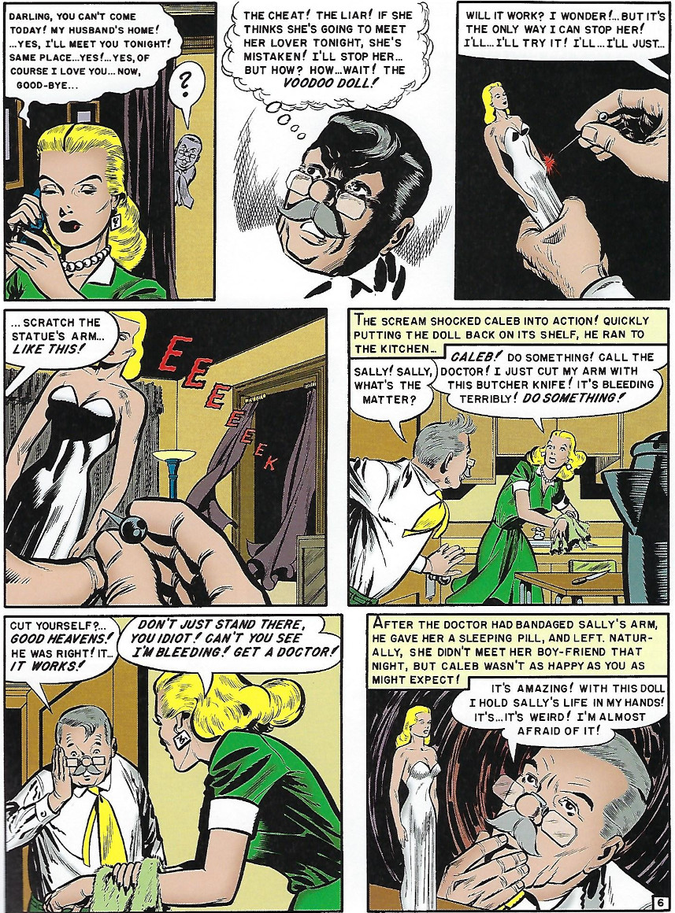

Characters ponder and debate with themselves. They dabble in shady and morally ambiguous behaviors. Lies and subterfuge are common motifs that add to the suspense of the tale. This mood persisted, even after the *Seduction of the Innocent* events in the mid-1950s. Explicit displays of horror and terror within the tales may have been blunted but the content continued to focus on the bizarre and fantastic (monsters, magic, or science fiction), the cautionary and the twist, as evidenced by this page from *Amazing Adventures* #1 showing what happens when science runs amok.

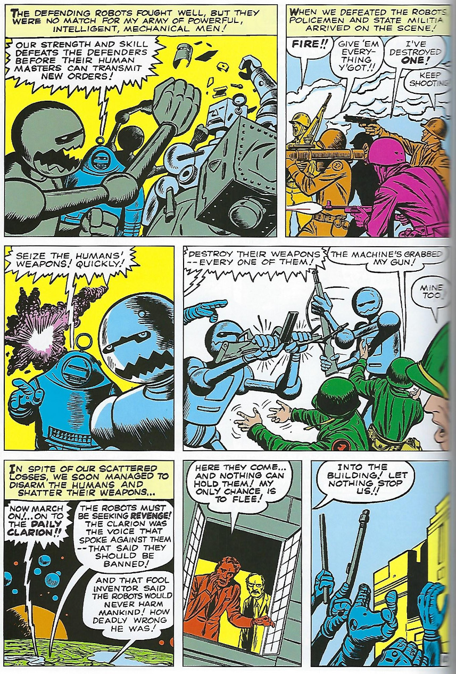

The bright colors had returned but not the bright attitude.

Perhaps ironically, the force of censorship that Wertham championed married the two earlier styles and made the fertile ground that gave birth to the revival of the superhero comic in the mid-1960s. Thus bringing back in popularity the wish-fulfillment he warned so vehemently against.

The next change in mood accompanied the social upheaval of the 1960s and brought along in its wake a fresh approach to page layout and content. Panels were no longer as clearly delineated as they had been before but became more ‘organic’. Artistic freedom matched a more liberal range in subject matter, covering institutional of societal woes like racism, drug use, and social unrest. Perhaps no single series made as big an impact as the Green Lantern/Green Arrow Tales. Consider the following page from *Green Lantern* #78 dealing with cults.

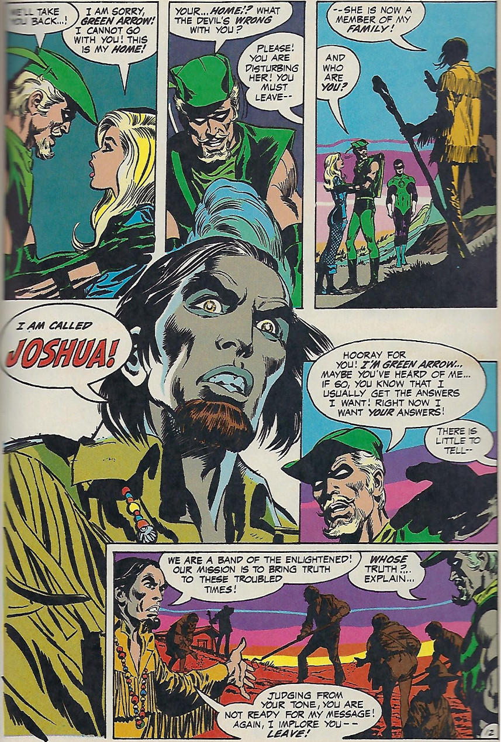

Mood, character tone, and dialog are an amalgam from the earlier eras. Bright costumed adventurers are found side-by-side with creepy elements and moody images. The dialog is also ambiguous, harkening in style to the horror comics of the 1950s but with a far more moral outlook. This deeper dialog was often wordier as well; action took a back seat to more in depth and drama and cerebral activity were more important that throwing punches and causing mayhem.

The 1980s saw a regression-to-the-mean as many comics backed away from the social issues and cerebral tales and returned to more action. But the nature of the action was different; super hero comics became grittier (e.g. the rise of the Punisher) even while the overall page look-and-feel became more traditional and the subject matter less controversial.

Still, not all creators were willing to let go of the freedom and flexibility to explore alternative subject matter. New genres and sub-cultures started springing up (Vertigo leading the forefront) and the 80s epoch would mark the last time that a common zeitgeist would exist across most of comics.

As an example, consider the stark difference between this page from *The Legion of Super-heroes* #291 (1982)

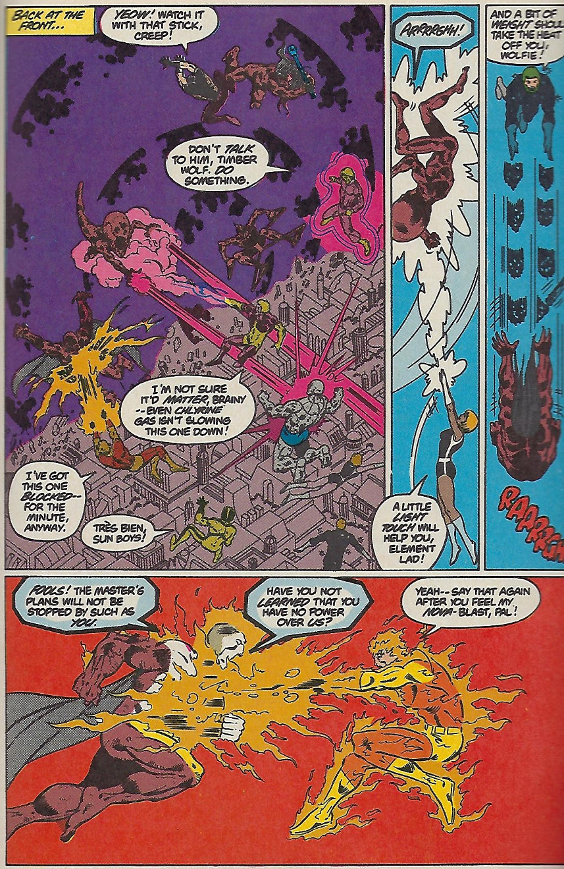

and this one from *Sandman* #3 (1988)

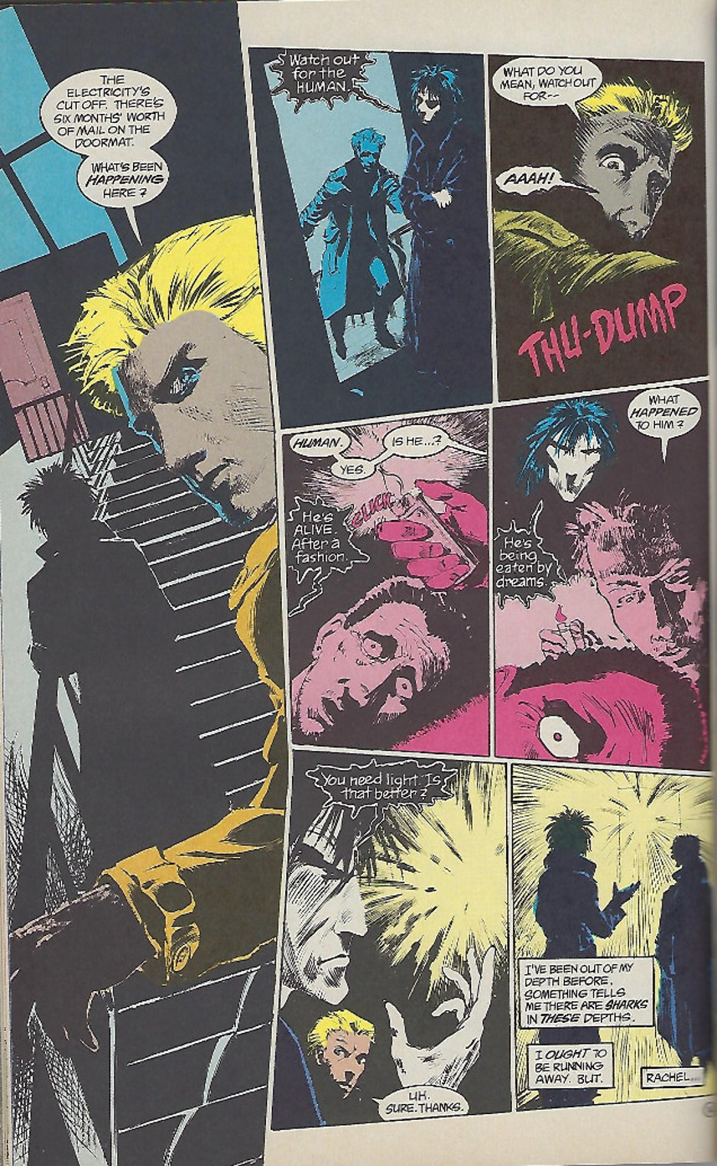

Both are from DC. The Legion story deals with end of the galaxy under the subjugation of Darkseid while the Sandman story deals with the torment of one person and degradation of a single person and yet the former is far lighter in color, line, mood and dialog than the latter.

This continuous fracturing only accelerated in the 1990s and 2000s. The primary difference in artistic mood being driven by technical matters rather than by a collective aim to provide uplifting messages or societal examination or the like. The rise of digital arts and new composing and printing processes was accompanied by the loss of gutters and panels. Images superimposed on images were the norm, regardless of subject matter and story mood. An excellent example of this is from *Darkseid versus Galactus: The Hunger* (1995)

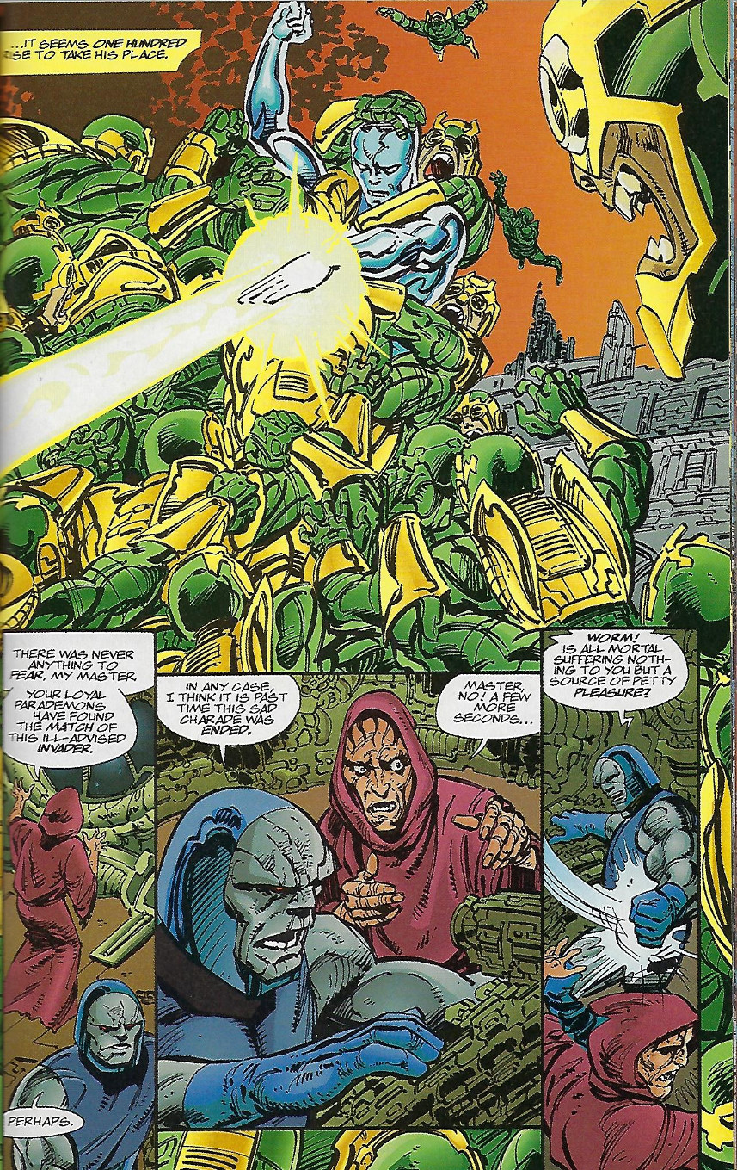

The only ‘zeitgeist’ that seemed to exist was one associated with technique and not content. This love affair with digital effects and eye candy has yet to subside, but there has been a movement back to a more traditional page layout and simpler art even as the number of genres, sub-genres, and sub-sub-genres have increased. That said, any visual similarities in page layout are drowned amidst the vast variety of art styles and moods. In terms of art, the industry has essentially splintered into ever smaller niches, much in the way cable television and the music industry has.

One common theme seems to exist in terms of content. Driven perhaps by political correctness and a sense of social justice, the content has become increasingly homogeneous, not in plot or subject matter, but in sensibility. This is a remarkably sad thing to note. After all, this very same industry, which struggled so-hard to free itself from the censorship and rigidly-defined topic areas imposed on it during the 1950s, is now rigidly self-policing any voices that differ from the accepted standard. Hopefully, this zeitgeist will soon pass into history.